PROPERTY CRM
User Guide
Step-by-step instructions for every feature and every role — manager, owner, finance, staff and tenant.
Item | Details
Software | Property CRM — web app for the office and owners, tenant app for tenants
Prepared by | BlueNova · Property CRM team
Version / date | Version 1.1 · October 2026
Website | Your Vercel address, e.g. https://<your-app>.vercel.app

If you are… | Start with
A manager setting up the system | Part 1, then Chapter 16 (Manager)
A property owner | Part 1, then Chapter 17 (Owner)
A finance person | Chapter 18 (Finance) and Chapter 10 (Rent)
Maintenance staff | Chapter 19 (Staff) and Chapter 11 (Repairs)
A tenant | Chapter 20 (Tenant app)

Screens in this guide show example data so that every feature is visible. A new account starts empty.

Contents
Contents 2
1. What Property CRM does 5
2. Roles: who does what 5
Who invites whom 6
3. Signing in 6
3.1 Sign in 6
3.2 First time: set your password from the invite 6
3.3 Forgot password 7
3.4 Sign out 7
3.5 Demo accounts 7
4. Finding your way around 8
4.1 The parts of the screen 8
4.2 The menu 8
4.3 Getting started steps 9
4.4 Colours 9
5. Owners 10
5.1 Add an owner and give them a login 10
5.2 Give an existing owner a login later 10
5.3 Read the owners list 11
6. Properties 11
6.1 Add a property 11
6.2 Edit a property 12
7. Units 12
7.1 Add many units at once 12
7.2 Add a single unit 13
7.3 Use the unit grid 13
7.4 The unit page 14
7.5 Change or delete a unit 14
8. Tenants 14
8.1 Add a tenant 14
8.2 The tenant’s page 16
8.3 Give the tenant the tenant app 16
8.4 Archive a tenant 16
9. Agreements (leases) 17
9.1 Create an agreement — 4 steps 17
9.2 Renew an agreement 17
9.3 End an agreement early 17
9.4 Agreements that run out 18
10. Rent 18
10.1 Every month (the routine) 19
10.2 Enter one rent by hand 19
10.3 Statuses 19
10.4 Fix a mistake 20
11. Repairs 21
11.1 Raise a repair ticket 21
11.2 Assign and follow a ticket 22
11.3 How fast? (SLA) 22
12. Expenses 23
13. Reports 23
14. People & access (My team) 25
14.1 Invite someone 25
14.2 Change, disable or re-invite 26
15. Search, notifications and activity log 26
15.1 Search 26
15.2 Notifications 26
15.3 Activity log 26
16. Manager (and Super Admin) 27
First-time setup 27
Every day 27
Every month 27
Home screen 28
17. Owner 28
First-time setup (follow the Getting started box on Home) 28
Every month 29
When something breaks 29
18. Finance 29
Every month 29
19. Maintenance staff 30
For each ticket 30
20. Tenant app 31
Use the app 31
Raise a repair request 31
Paying rent 32
21. Automatic reminders 33
22. Problems and fixes 33
23. Glossary 34

PART 1
The basics

1. What Property CRM does
Property CRM keeps every owner, property, unit, tenant, rent agreement, monthly rent and repair in one place, instead of Excel sheets, registers and WhatsApp messages. Open any unit and you see at once who lives there, the rent, the agreement dates, what is due and its repair history.
Work always happens in the same order:
Step | What | Where in the menu
1 | Add the owner and give them a login | Owners
2 | Add the owner’s property (building, shop, office) | Properties
3 | Add the property’s units (flats, shops) | Properties → open the property
4 | Add the tenant | Tenants
5 | Create the agreement that links tenant + unit | Agreements
6 | Record rent every month | Rent
7 | Handle repairs, record expenses, read reports | Repairs · Expenses · Reports

2. Roles: who does what
Every person signs in with their own email. What they see depends on their role.
Role | What they do | What they see
Super Admin | Sets up the company; can do everything | Everything
Manager | Looks after owners: adds owners and gives them logins; can help with any property | All owners and all properties
Owner | Adds their own properties, units, tenants, agreements and rent; invites their own staff and finance person | Only their own properties
Finance | Works for an owner: records rent and expenses, reads reports | Only that owner’s properties
Maintenance Staff | Works for an owner: fixes repairs | Only repairs assigned to them
Tenant | Uses the tenant app: sees lease and rent, raises repair requests | Only their own home

Who invites whom
Person | Can invite
Super Admin | Managers, owners, staff, finance
Manager | Owners (Owners page), staff and finance (People & access)
Owner | Their own staff and finance person (My team) and their tenants (tenant page or agreement)
Finance, Staff, Tenant | Nobody
Remember: staff and finance always “work for” someone. When an owner invites them they automatically see only that owner’s properties.

3. Signing in

3.1 Sign in
Who can do this: Everyone
- Open the website address.
- Type your email and password.
- Click Sign in. You land on your home screen (tenants go straight to the tenant app; staff go to Repairs).
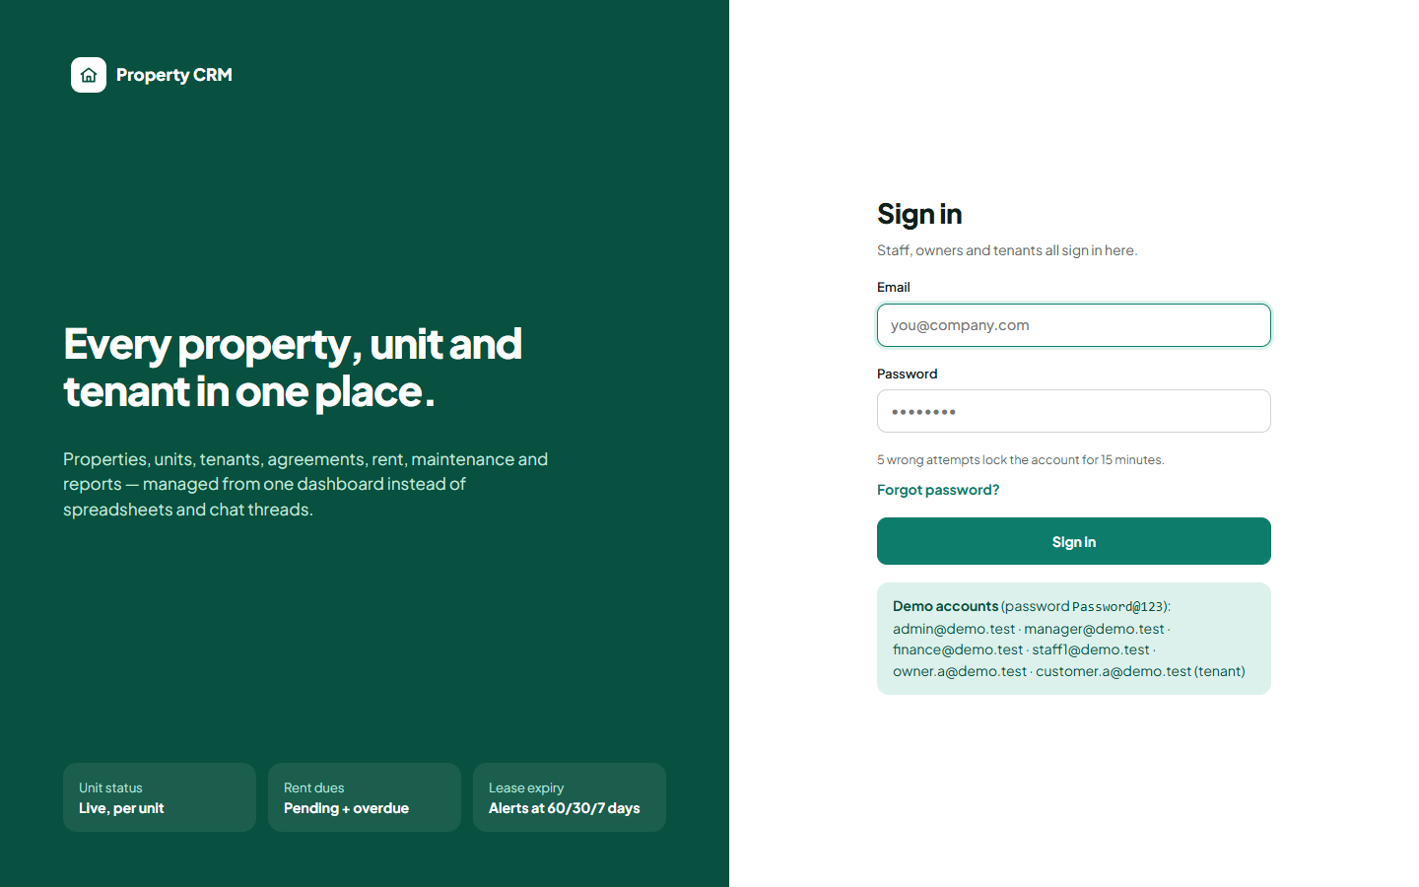
Sign-in page
Security: after 5 wrong passwords the account is locked for 15 minutes.

3.2 First time: set your password from the invite
- You receive an invite link by email — or your manager/owner sends it on WhatsApp.
- Open the link, type a password (at least 8 characters) twice.
- Click Set password and continue. You are signed in. The link works once and expires after 48 hours.

3.3 Forgot password
- On the sign-in page click Forgot password?
- Enter your email → Send reset link.
- Open the email link (valid 30 minutes) and choose a new password.

3.4 Sign out
Click the arrow next to your name at the bottom of the left menu (tenants: Profile → Sign out).

3.5 Demo accounts
These practice logins all use the password Password@123. Change or disable them before real use.
Email | Role | In the demo
admin@demo.test | Super Admin | Everything
manager@demo.test | Manager | Looks after all owners
owner.a@demo.test | Owner | Owner A
finance@demo.test | Finance | Works for Owner A
staff1@demo.test | Maintenance Staff | Works for Owner A
customer.a@demo.test | Tenant | Owner A’s tenant

4. Finding your way around
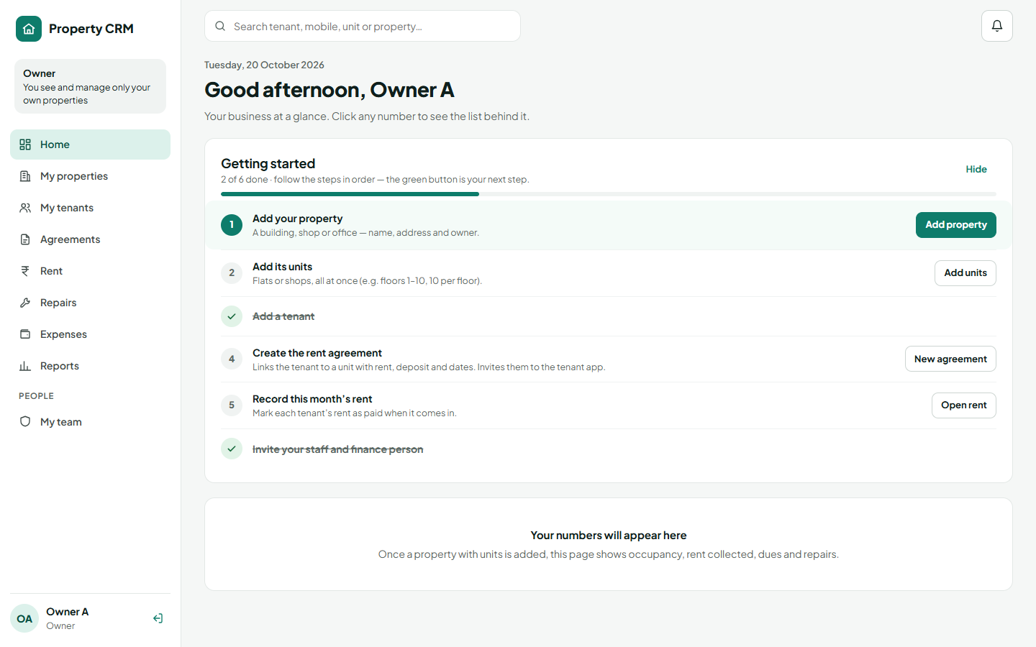
The owner’s home screen with the left menu and the Getting started steps

4.1 The parts of the screen
Part | What it does
Box at the top of the menu | Says who you are and what you look after, e.g. “Owner · You see and manage only your own properties”.
Left menu | Shows only the pages your role can use. On a phone open it with the ☰ button.
Grey line under each page title | Explains what the page is for and what to do there.
Search bar (top) | Type a tenant name, mobile, unit number or property code and jump straight to it.
Bell (top right) | Notifications: overdue rent, leases ending, new repairs. A red number = unread.

4.2 The menu
Menu item | Used for | Seen by
Home | Getting started steps and the business at a glance | Admin, manager, owner, finance
Owners | Add owners and give them logins | Admin, manager
Properties / My properties | Buildings and their units | All except tenants
Tenants / My tenants | People who rent | Admin, manager, owner, finance
Agreements | Rent agreements (tenant + unit) | Admin, manager, owner, finance
Rent | Monthly rent and payments received | Admin, manager, owner, finance
Repairs | Repair tickets | All except tenants
Expenses | Money spent on properties | Admin, manager, owner, finance
Reports | Ready answers with Excel export | Admin, manager, owner, finance
People & access / My team | Invite and manage people | Admin, manager, owner
Activity log | Who changed what, when | Admin, manager

4.3 Getting started steps
Managers and owners see a Getting started box on Home. It lists the setup steps in order; the step with the green button is the next thing to do. Finished steps are ticked. Click Hide to put it away (a link brings it back).
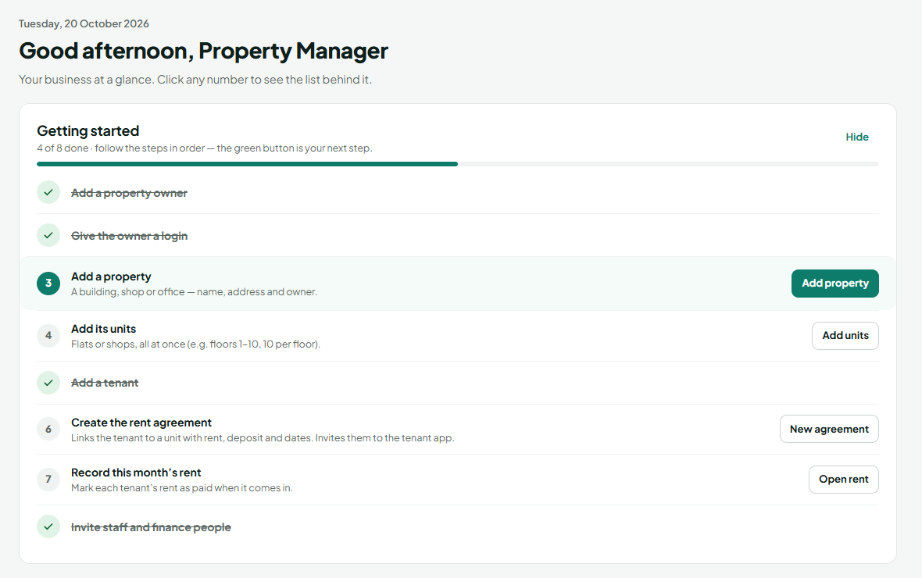
Getting started for a manager — step 3 is next

4.4 Colours
Colour | Units | Rent and repairs
Teal | Occupied | Agreement active
Blue | Vacant | In progress, Medium priority
Amber | Reserved | Pending, lease ending soon, High priority
Red | Maintenance | Overdue rent, Urgent, late repair
Green | — | Paid, Resolved, Low priority
PART 2
Every feature, step by step

5. Owners
Who can do this: Super Admin, Manager
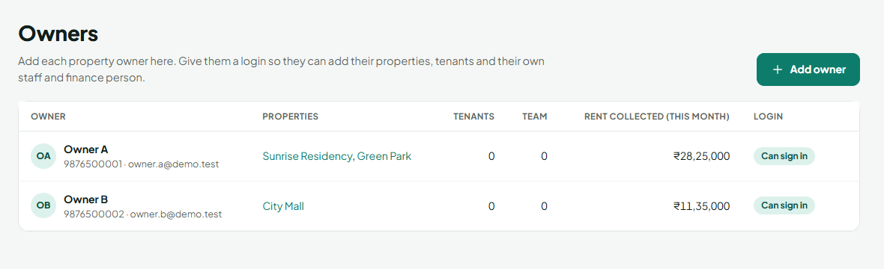
Owners: properties, tenants, team, rent collected and login status

5.1 Add an owner and give them a login
- Click Owners in the menu, then Add owner.
- Type the owner’s name, mobile and email (PAN and address are optional).
- Leave Give this owner a login ticked.
- Click Add owner & send login.
- If email is set up, the owner receives the invite. If not, a box shows the link — click Copy link or Share on WhatsApp and send it to the owner.
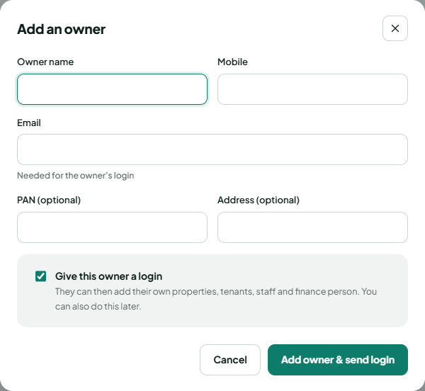
Add an owner

5.2 Give an existing owner a login later
- On Owners, find the owner with “No login”.
- Click Send login invite (or Resend invite if they lost the first one).
- Send them the link if it is shown.

5.3 Read the owners list
- Properties — click a name to open it, or + Add property if they have none.
- Tenants / Team — how many tenants and staff/finance people the owner has.
- Login — “Can sign in”, “Invite sent” or “No login”.

6. Properties
Who can do this: Super Admin, Manager (for any owner), Owner (for themself)
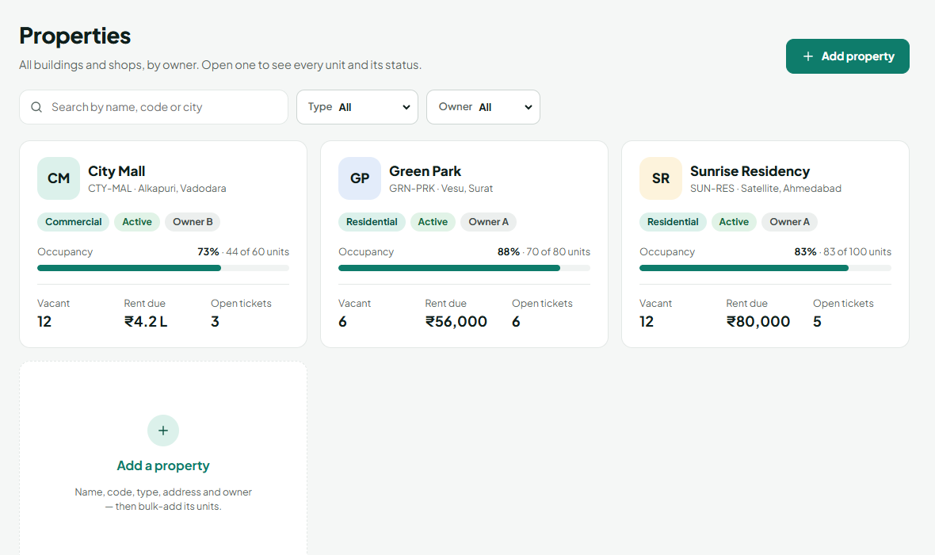
Properties with occupancy, rent due and open repairs

6.1 Add a property
- Click Properties (owners: My properties), then Add property.
- Type the name and a short code (letters/numbers, e.g. SUN-RES).
- Choose the type (Residential, Commercial, Office, Shop, Warehouse, Mixed) and status.
- Type the address, area, city, state and 6-digit PIN code.
- Managers only: choose the Owner (or click + Add a new owner). Owners skip this — the property is automatically theirs.
- Click Create property. You are taken to the property so you can add units.
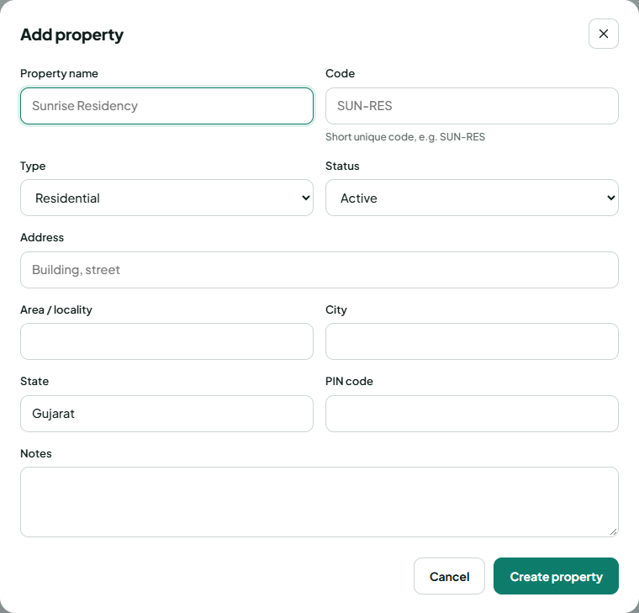
Add property (as an owner — no owner field)

6.2 Edit a property
- Open the property.
- Click Edit, change the details, click Save changes.
A property with active agreements cannot be archived; end the agreements first.

7. Units
Who can do this: Super Admin, Manager, Owner

7.1 Add many units at once
- Open the property and click Bulk add units.
- Choose the numbering style: By floor (101, 102 … 1001) or Number range (G-01 … G-20).
- Type the floors / numbers, unit type (2BHK, Shop…), area, expected rent and deposit.
- Check the line at the bottom (“Creates 100 units: 101 … 1010”).
- Click Add units. Unit numbers that already exist are skipped.
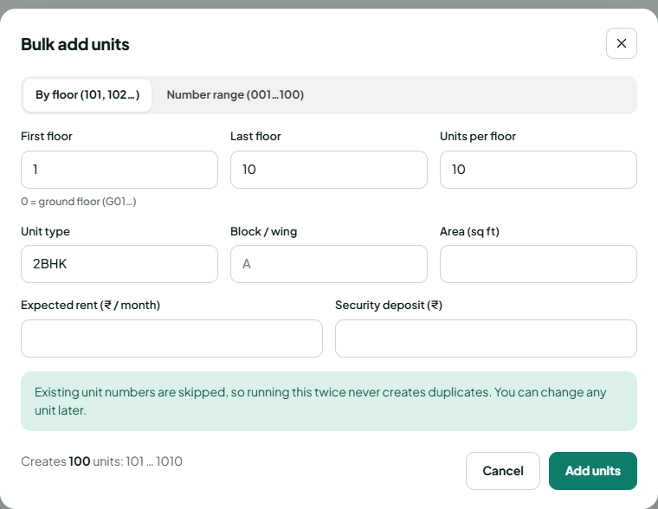
Bulk add units

7.2 Add a single unit
- Open the property → Add one unit.
- Type unit number, floor, type, rent and deposit → Add unit.

7.3 Use the unit grid
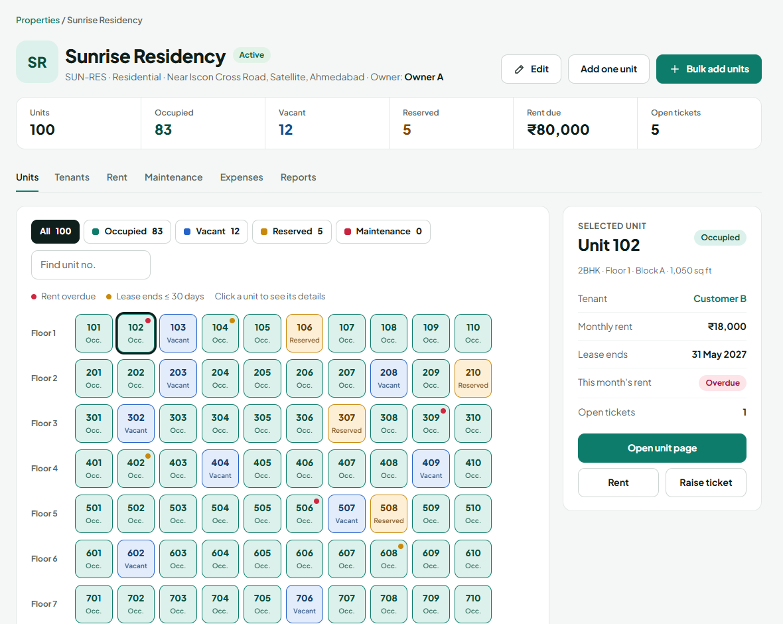
Property page: every unit as a coloured tile
- Each tile is one unit; its colour is its status. A red dot = rent overdue; an amber dot = agreement ends within 30 days.
- Filter with the buttons (Occupied, Vacant…) or type a unit number in Find unit no.
- Click a tile: the right panel shows tenant, rent, agreement end and this month’s rent, with buttons Open unit page, Rent, Raise ticket or Create agreement for this unit.

7.4 The unit page
Everything about one unit: details, current tenant and agreement (days left), rent history, pending amount, repairs, notes and an activity timeline of every change.
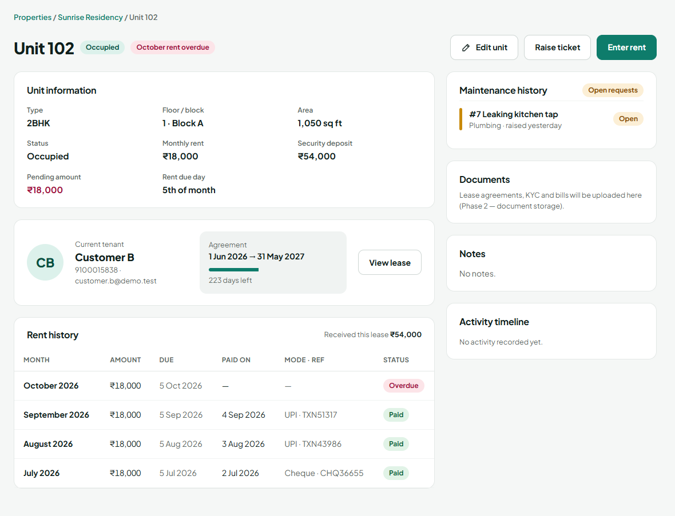
Unit page

7.5 Change or delete a unit
- On the unit page click Edit unit.
- Change number, type, area, rent, deposit or status (Vacant, Reserved, Maintenance) → Save.
“Occupied” is set only by an agreement. A unit can be deleted only when it is not occupied.

8. Tenants
Who can do this: Super Admin, Manager, Owner (their own tenants). Finance can view.

8.1 Add a tenant
- Click Tenants (owners: My tenants) → Add tenant.
- Choose Individual or Company.
- Type the full name and a 10-digit mobile (each mobile can be used only once).
- Type the email — needed for the tenant app and reminders.
- Optional: alternate mobile, address, ID type and number, emergency contact, notes.
- Click Add tenant.
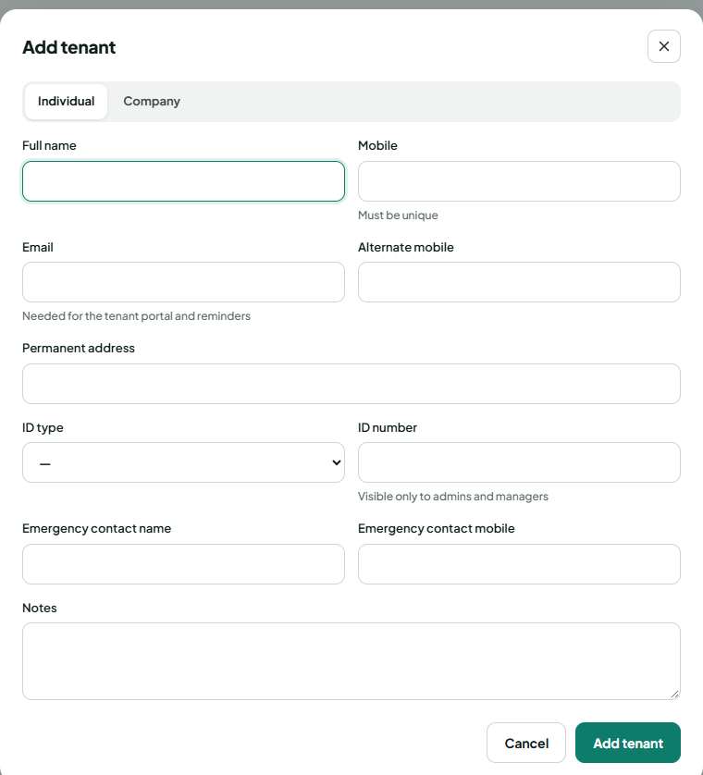
Add tenant

8.2 The tenant’s page
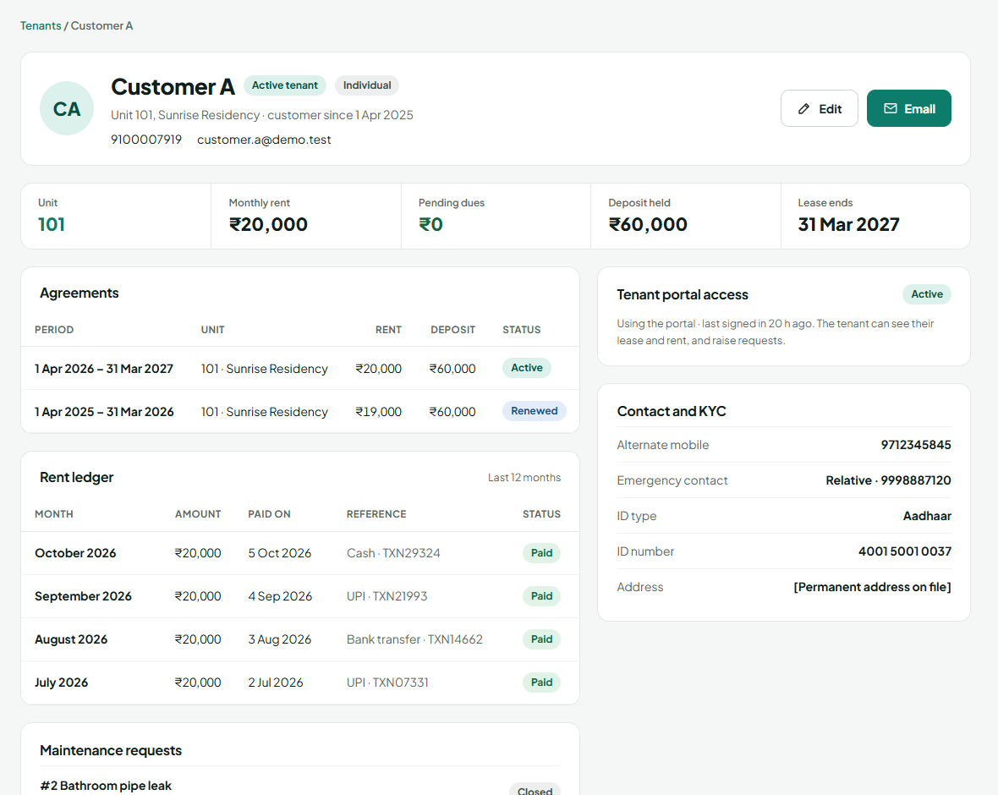
Tenant page: agreements, rent ledger, requests, app access and KYC
Status changes by itself: No lease yet → Active (agreement started) → Previous (agreement ended). ID numbers are hidden (XXXX1234) from everyone except the admin and managers.

8.3 Give the tenant the tenant app
- Make sure the tenant has an email address (Edit if not).
- Click Send portal invite on the tenant’s page — or tick “Email a tenant portal invite” when creating the agreement.
- Send the link if one is shown (Copy link / Share on WhatsApp).

8.4 Archive a tenant
On a tenant with no active agreement, click Archive tenant. Their history is kept.

9. Agreements (leases)
Who can do this: Super Admin, Manager, Owner. Finance can view.

9.1 Create an agreement — 4 steps
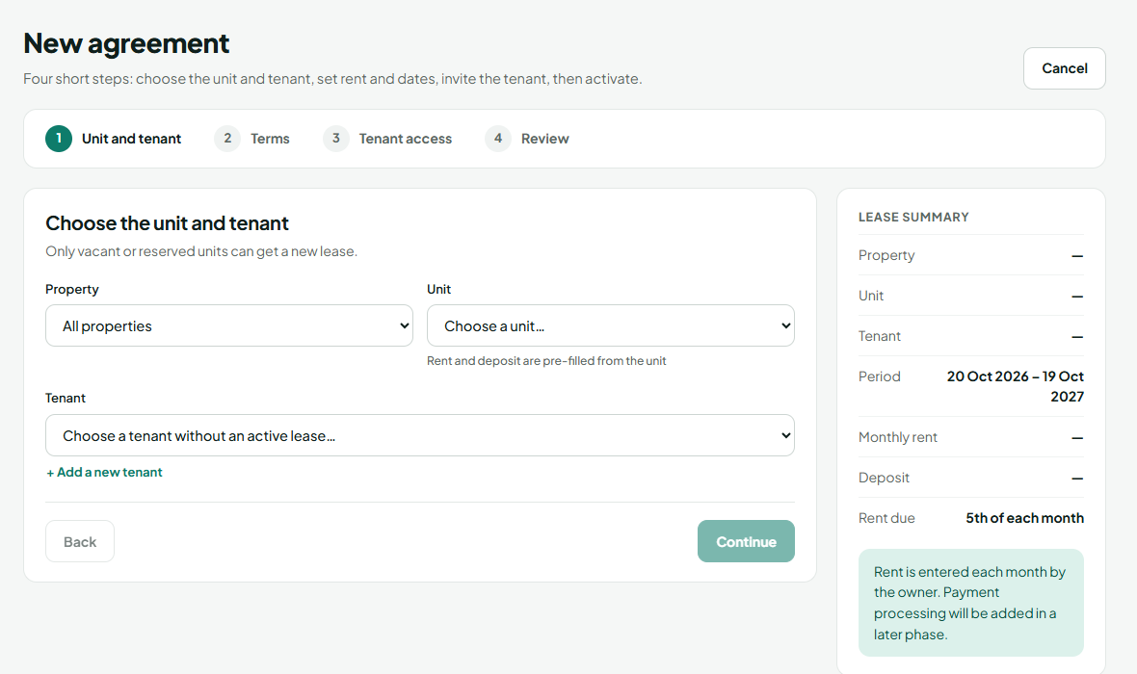
New agreement
- Unit and tenant — click Agreements → New agreement (or Create agreement on a vacant unit). Pick the unit (only vacant or reserved units are listed) and the tenant. + Add a new tenant is right there.
- Terms — start date (end date fills in one year later), monthly rent and deposit (copied from the unit), rent due day (1–28), notice period, increase on renewal (%), renewal terms.
- Tenant access — tick to invite the tenant to the tenant app.
- Review — check the summary and click Activate agreement, or Save as draft to finish later.
What happens on activation: the unit becomes Occupied, the tenant becomes Active, and reminders are planned 60, 30 and 7 days before the end date. A unit can never have two active agreements.

9.2 Renew an agreement
- Open the agreement (Agreements, or View lease on the unit/tenant page).
- Click Renew lease. New dates and the new rent (with the agreed increase) are filled in — change them if needed.
- Click Renew. The old agreement becomes Renewed and a new active one starts.

9.3 End an agreement early
- Open the agreement → End early.
- Choose the last day and type the reason → End lease.
- The unit becomes Vacant and the tenant becomes Previous.

9.4 Agreements that run out
Nothing to do: the day after the end date the agreement becomes Expired, the unit becomes Vacant, and managers are notified. Use the tabs on Agreements — Active, Expiring ≤ 60 days, Drafts, Ended — to plan renewals.
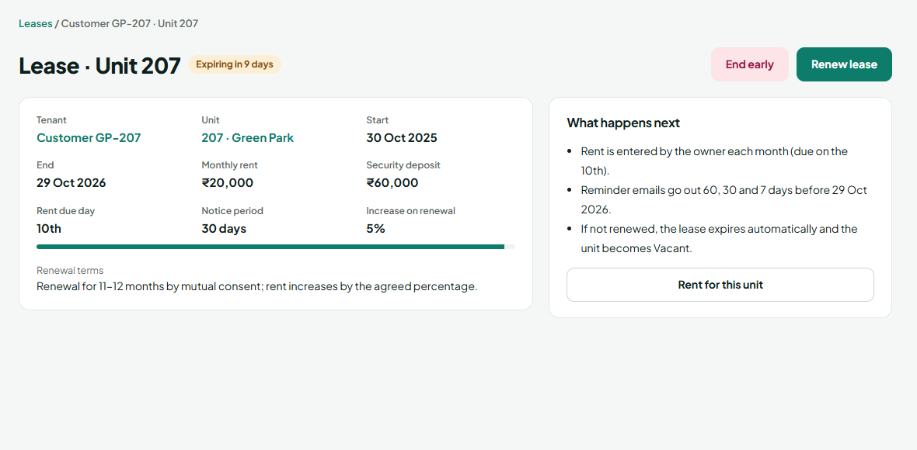
An agreement close to its end, with Renew lease and End early

10. Rent
Who can do this: Super Admin, Manager, Owner, Finance
Rent is entered each month (it is not paid online yet). When a tenant pays you, you record it here.
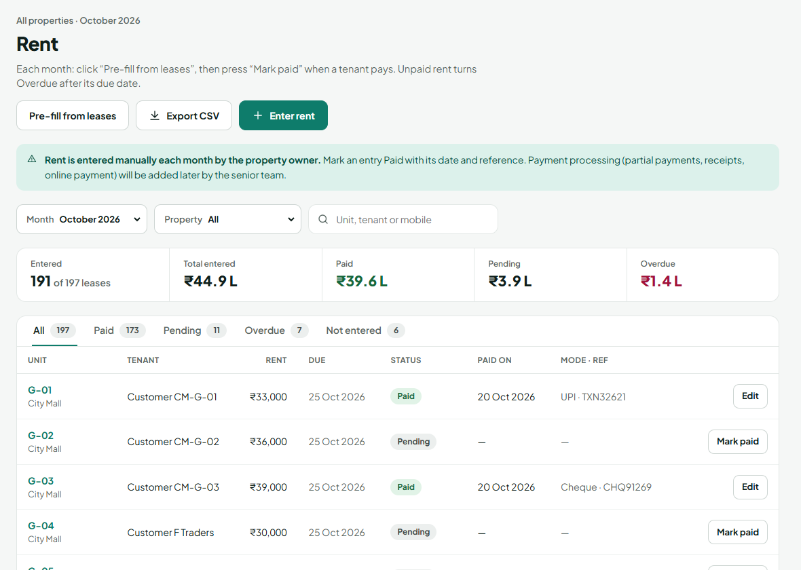
Rent: totals, status tabs, one row per agreement

10.1 Every month (the routine)
- Open Rent. The current month is selected.
- Click Pre-fill from leases once. This creates a Pending row for every active agreement, with its rent and due date.
- When a tenant pays, click Mark paid on their row.
- Choose Paid, enter the paid-on date, mode (UPI, bank transfer, cash, cheque, card) and reference (UTR or cheque no.).
- Click Save entry. The row turns green.
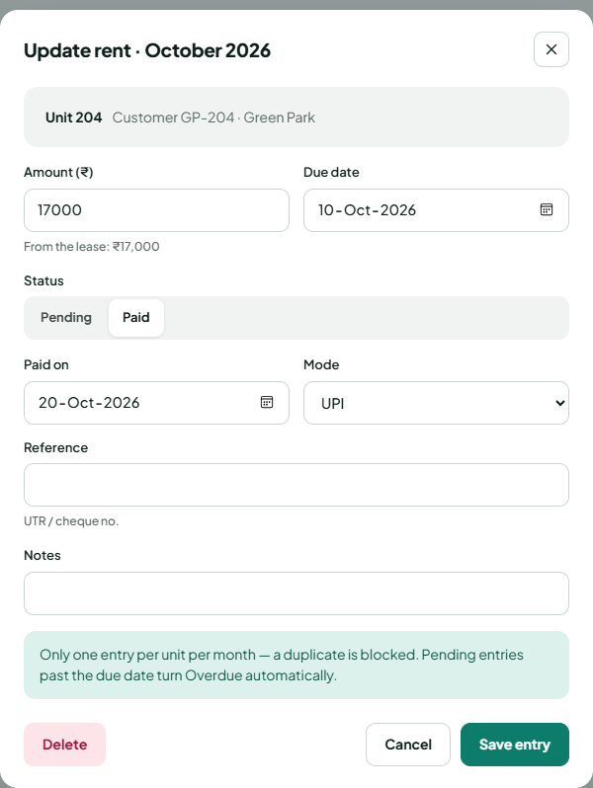
Marking rent as paid

10.2 Enter one rent by hand
- Click Enter rent (or Enter on a “Not entered” row).
- Pick the unit, check the amount and due date, choose Pending or Paid → Save entry.

10.3 Statuses
Status | Meaning | What to do
Not entered | No rent recorded this month | Click Enter, or Pre-fill from leases
Pending | Recorded, not paid, due date not passed | Mark paid when it arrives
Overdue | Unpaid after the due date (set every night) | Follow up; the tenant is reminded by email
Paid | Paid, with date, mode and reference | Nothing
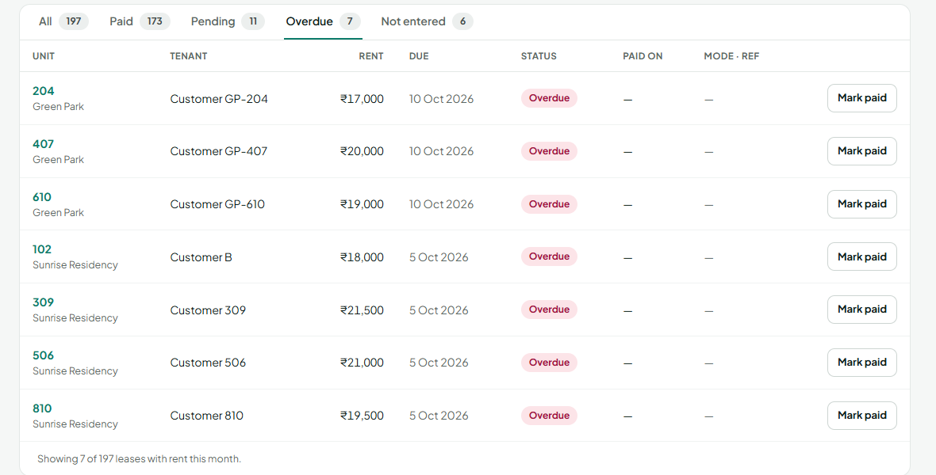
The Overdue tab lists everyone who is late

10.4 Fix a mistake
- Wrong amount or date: click Edit on the row, correct it, Save entry.
- Marked paid by mistake: Edit → choose Pending → Save.
- Entered by mistake: open it → Delete (only possible while not paid).
Rules: one entry per unit per month; Paid always needs a date and mode. Change Month at the top to see past months; Export CSV downloads the month for Excel.

11. Repairs
Who can do this: Raise: Super Admin, Manager, Owner, Staff and tenants (tenant app). Assign: Super Admin, Manager, Owner. Work on: assigned staff. Close: Manager, Owner, Admin.
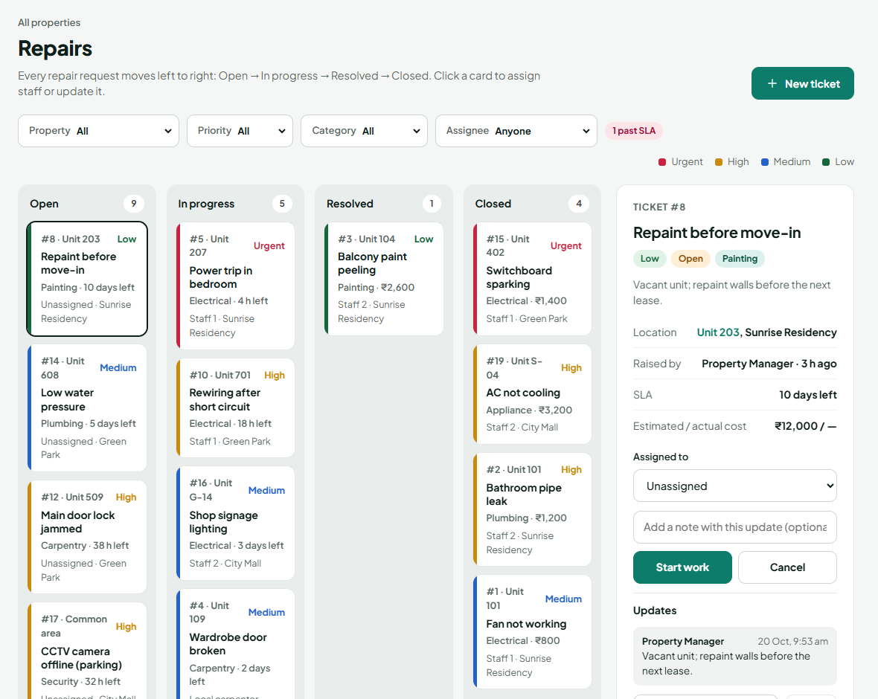
Repairs board and ticket details

11.1 Raise a repair ticket
- Click Repairs → New ticket (or Raise ticket on a unit).
- Choose the property and unit (leave the unit empty for a common area such as the lift or parking).
- Choose the category and priority, type a short title and a description.
- Optional: choose who will do it and an estimated cost.
- Click Raise ticket. Managers and the assigned person are notified.
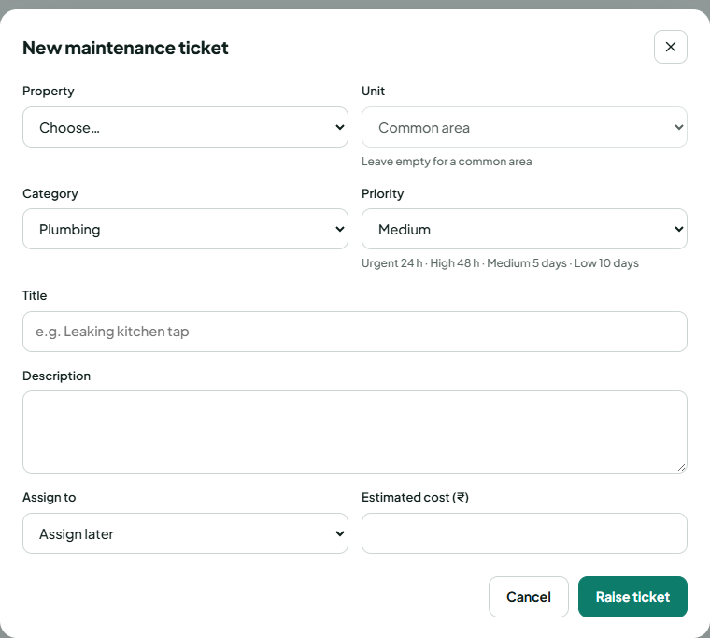
New repair ticket

11.2 Assign and follow a ticket
- Click a ticket card on the board — its details open on the right.
- Choose Assigned to (owners see their own staff).
- As work progresses press the buttons below; add a short note each time if useful.
Now | Button | Becomes
Open | Start work | In progress
Open | Cancel | Cancelled (duplicate or not needed)
In progress | Mark resolved | Resolved — tenant and manager are told
Resolved | Close ticket (type the actual cost) | Closed — cost is added to Expenses
Resolved | Reopen | Reopened → Start work again

11.3 How fast? (SLA)
Priority | Fix within
Urgent | 24 hours
High | 48 hours
Medium | 5 days
Low | 10 days
Cards show the time left. Late tickets show SLA breached in red and appear on Home under “Needs your attention”.

12. Expenses
Who can do this: Super Admin, Manager, Owner, Finance
- Click Expenses → Add expense.
- Choose the property and category (Maintenance, Utility, Vendor, Salary, Tax, Insurance, Admin, Other).
- Type amount, date, paid to and mode → Save.
Repair costs are added automatically when a ticket is closed (they show “Ticket #…”). Use Month, Property and Category at the top to filter. Click × on a row to delete a manual expense.
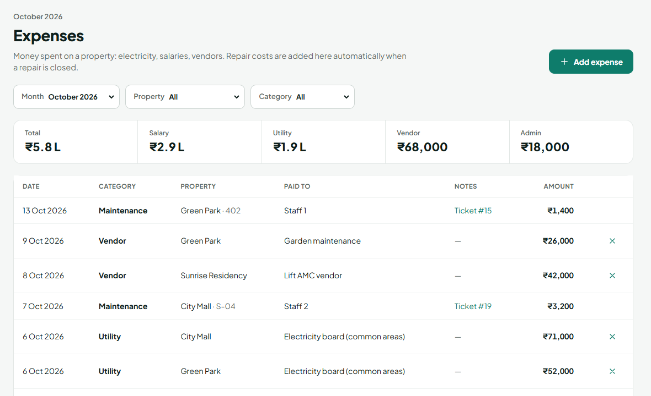
Expenses for a month

13. Reports
Who can do this: Super Admin, Manager, Owner, Finance (each sees only their own properties)
- Click Reports.
- Pick a question on the left.
- Choose Property and Month at the top.
- Click Export CSV (opens in Excel) or Print / PDF.
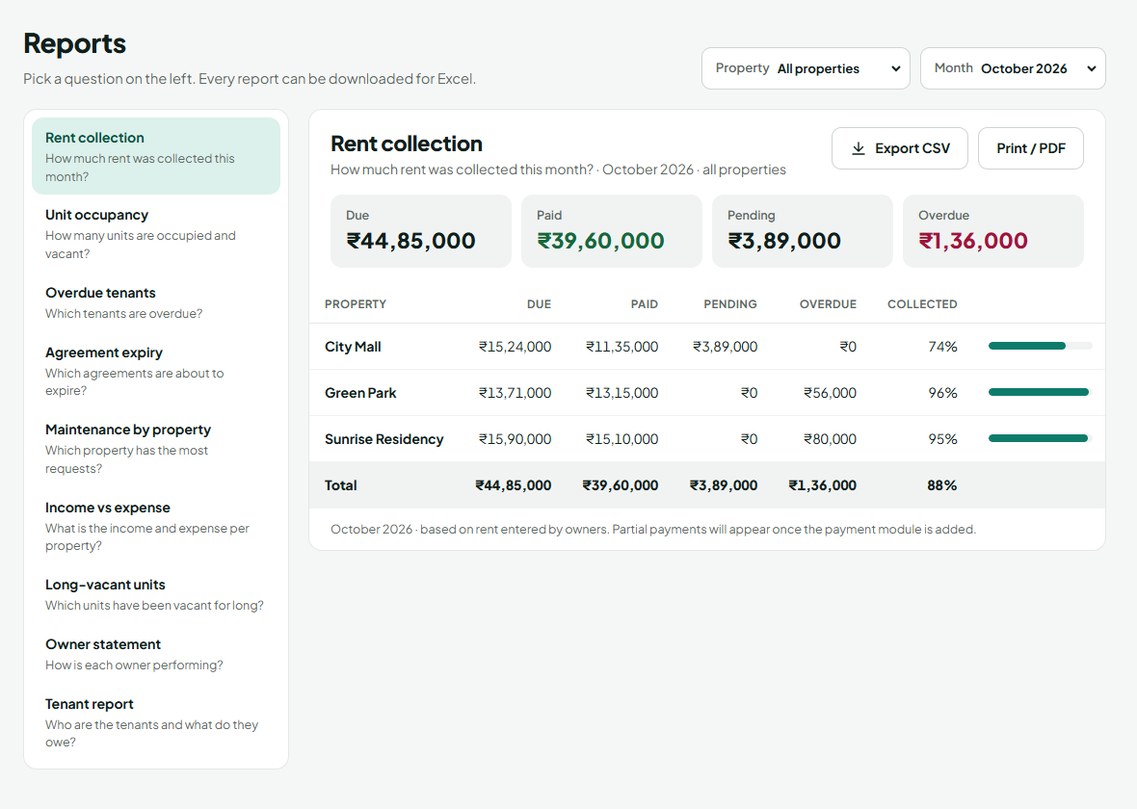
Reports
Report | Answers
Rent collection | How much rent came in this month, per property?
Unit occupancy | How many units are occupied, vacant, reserved?
Overdue tenants | Who is late, by how much, for how many days?
Agreement expiry | Which agreements end in the next 60 days?
Maintenance by property | Where are the most repairs and repair costs?
Income vs expense | Income, expenses and net per property
Long-vacant units | Which units have been empty longest?
Owner statement | Income, expenses and net per owner
Tenant report | All tenants with unit, rent and dues

14. People & access (My team)
Who can do this: Super Admin and Manager (People & access), Owner (My team)
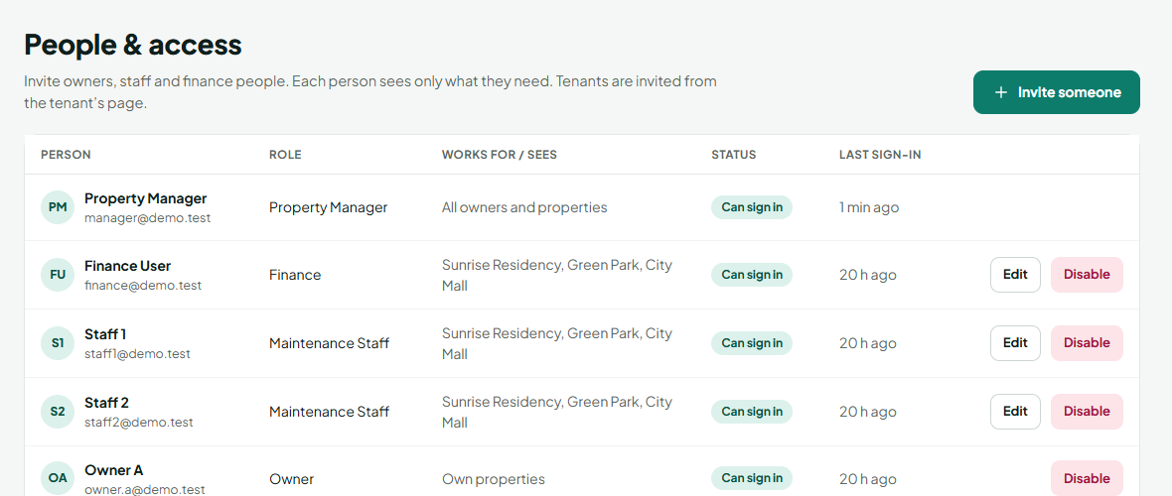
People & access

14.1 Invite someone
- Click People & access (owners: My team) → Invite someone.
- Who are you adding? — click a card: Owner, Finance or Maintenance Staff (owners see only Finance and Staff).
- Their details — name, mobile (required for owners) and email.
- Who do they work for? (managers, for finance/staff) — choose An owner and pick the owner, or Our company and tick the properties.
- Click Send invite, then send the link if one is shown.
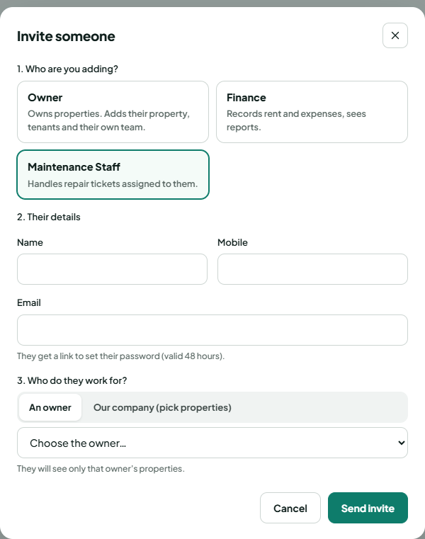  Manager inviting staff | 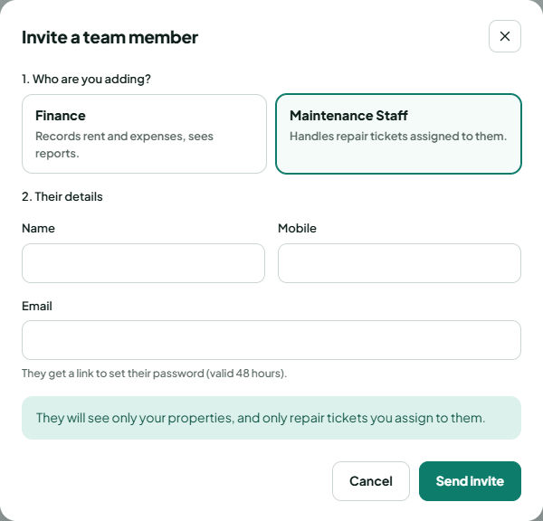  Owner inviting their team

14.2 Change, disable or re-invite
- Edit — change name, mobile, role (finance ↔ staff) or who they work for.
- Disable — they can no longer sign in (immediately). Enable gives access back.
- Resend invite — for someone who never set a password; creates a new link.

15. Search, notifications and activity log

15.1 Search
Type at least 2 letters in the search bar: tenant name, mobile, unit number or property name/code. Click a result to open it.

15.2 Notifications
Click the bell. Click a notification to open the related page; Mark all read clears the red number. Reminders are created every night (see chapter 21).

15.3 Activity log
Who can do this: Super Admin, Manager
Activity log lists every important change — who, what and when. The same history appears as a timeline on each unit page.
PART 3
Guides for each role

16. Manager (and Super Admin)
You look after all owners and their properties. The Super Admin can do everything a manager can, and can also add managers.

First-time setup
- Owners → Add owner for each owner, with Give this owner a login ticked.
- Send each owner their invite link.
- Optionally add properties and units for owners who prefer you to do it (Properties → Add property → choose the owner).
- People & access → Invite someone for staff and finance people, and choose who they work for.

Every day
- Open Home and work through Needs your attention: overdue rent, agreements ending, urgent or late repairs.
- Open Repairs: assign new tickets, close resolved ones.
- Check the bell for new notifications.

Every month
- Make sure every owner’s rent is entered (Rent → Not entered tab should be empty).
- Review Agreements → Expiring ≤ 60 days and plan renewals.
- Run Reports → Owner statement and send it to owners.

Home screen
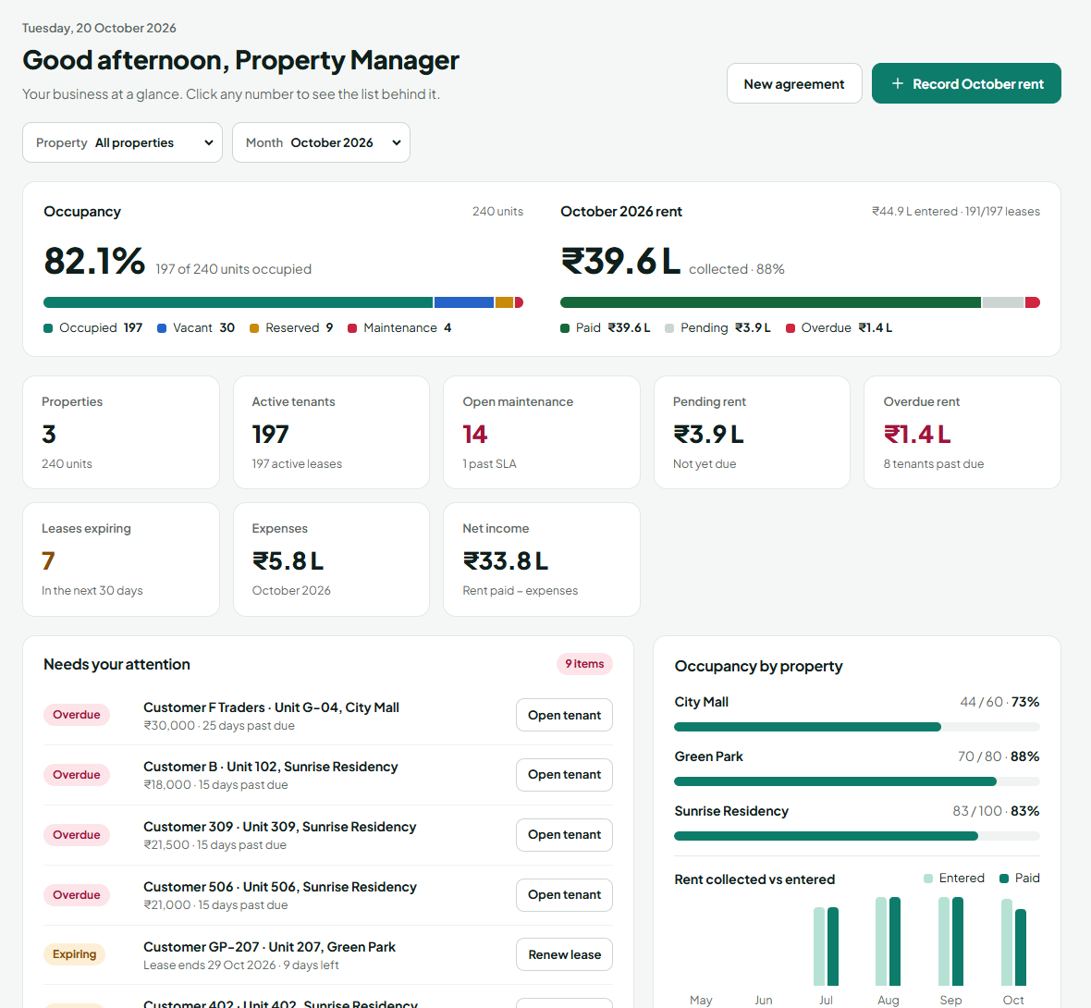
Manager’s Home with occupancy, rent, key numbers and items needing attention
Click any number card to open the list behind it.

17. Owner
You manage your own properties. You see only your properties, your tenants and your team.

First-time setup (follow the Getting started box on Home)
- Set your password from the invite link.
- My properties → Add property (it is automatically yours).
- Open the property → Bulk add units.
- My tenants → Add tenant for each tenant.
- Agreements → New agreement for each tenant and unit; tick the tenant-app invite.
- Rent → Pre-fill from leases, then mark payments.
- My team → Invite team member: your maintenance staff and your finance person.

Every month
- Rent: Pre-fill from leases on the 1st; Mark paid as payments come in.
- Check the Overdue tab and follow up.
- Expenses: add electricity, salaries and other bills.
- Reports → Income vs expense to see your profit.

When something breaks
- Repairs → New ticket (or a tenant raises it from their app).
- Assign it to your staff.
- When staff mark it resolved, check and Close ticket with the actual cost.
You cannot: see other owners’ properties, add owners or managers, or see the activity log. Ask your manager for help with those.

18. Finance
You record money for the owner you work for: rent and expenses. You see that owner’s properties only.

Every month
- Rent → choose the month → Pre-fill from leases.
- As tenants pay, Mark paid with date, mode and reference.
- Check the Overdue tab and tell the owner/manager who is late.
- Expenses → Add expense for each bill.
- Reports → Rent collection, Overdue tenants, Income vs expense → Export CSV for accounts.
You cannot: create properties, tenants or agreements, or change repairs. You can view them.

19. Maintenance staff
You fix repairs assigned to you. Your home screen is Repairs, showing only your tickets.
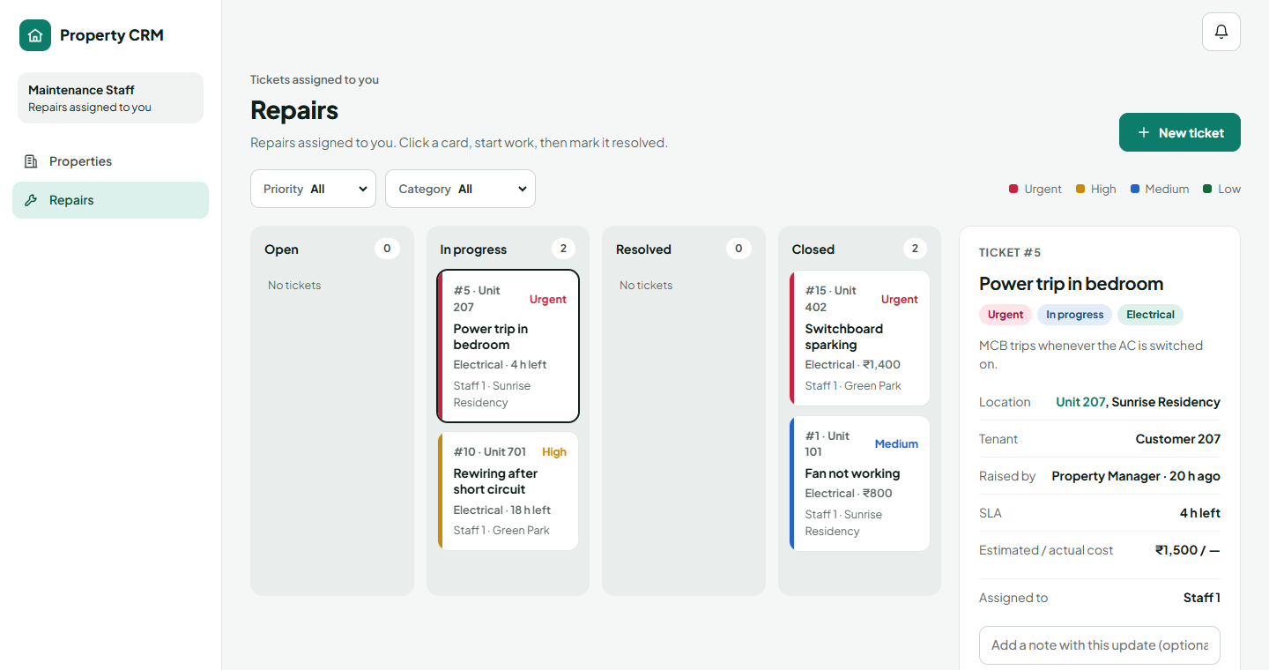
Staff see only their own tickets

For each ticket
- Click the ticket card to read the details and location.
- Click Start work when you begin.
- Add updates in Write an update… (e.g. “parts ordered”).
- When finished, click Mark resolved and add a short note. The tenant and manager are told.
- The owner or manager checks the work and closes it. If the problem is still there it is Reopened and comes back to you.
You can also: raise a new ticket you notice (Repairs → New ticket).

20. Tenant app
For tenants. Works on any phone browser. You get the link from your owner or manager.
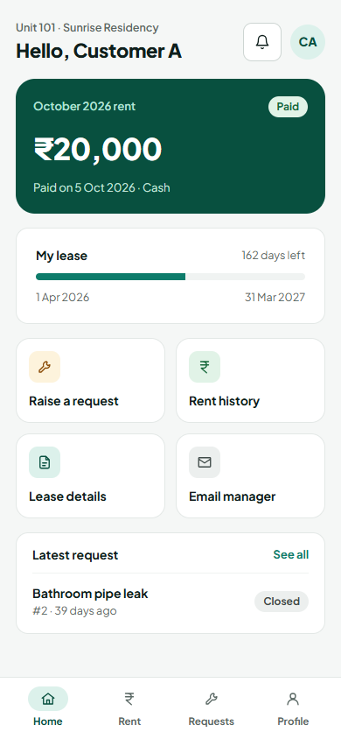  Home: rent and lease | 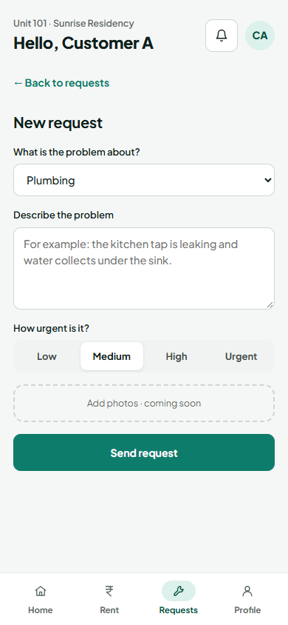  Raising a repair request

Use the app
Tab | What you can do
Home | See this month’s rent and whether it is paid, total pending, days left on your lease
Rent | Month-by-month rent history with paid dates
Requests | Raise a repair request and follow it until it is fixed
Profile | See lease details; change alternate mobile and emergency contact; sign out

Raise a repair request
- Tap Requests → New request (or Raise a request on Home).
- Choose what the problem is about and describe it.
- Choose how urgent it is.
- Tap Send request. You get an email when it is resolved.

Paying rent
Pay your owner as usual (UPI, bank transfer, cash or cheque). They record it, and it then shows as Paid in the app. Online payment in the app will come in a later version.
PART 4
Reference

21. Automatic reminders
Every night at 00:30 (India time) the system checks and sends reminders — under the bell and, once email is set up, by email.
When | Who is told
Rent due in 3 days | Tenant
Rent becomes overdue | Tenant, managers, owner
Agreement ends in 60, 30 and 7 days | Managers, owner, tenant
Agreement expired | Managers
New ticket or ticket assigned | Managers, assigned staff
Ticket resolved or closed | Tenant, managers
Ticket past its time limit | Managers

22. Problems and fixes
Problem | What to do
I can’t see a property | Owners see only their own. Staff/finance see only the owner they work for — ask the owner or manager to check “Works for” in People & access.
“Only vacant or reserved units can get a new lease” | The unit already has an active agreement or is under maintenance. End it or change the unit status first.
“Rent … is already entered” | Each unit has one entry per month — use Edit or Mark paid on its row.
Cannot mark rent as Paid | Paid needs a paid-on date and a payment mode.
Invite not received | Check the email on their profile, then Resend invite — or copy the link and send it on WhatsApp.
Invite link expired | Links work once and last 48 hours. Ask for a new invite.
Account locked | Wait 15 minutes or use Forgot password.
Website slow on the first visit | The free server sleeps when idle; the first page can take up to a minute.
Staff cannot close a ticket | Staff mark it Resolved; the owner or manager closes it.

23. Glossary
Word | Meaning
Owner | The person a property belongs to
Unit | One rentable space: flat, shop, office or warehouse bay
Agreement / lease | Links one tenant to one unit for a period, with rent and deposit
Due day | Day of the month rent is due (1–28)
Pre-fill | Creating this month’s Pending rent rows for all agreements in one click
Overdue | Rent unpaid after its due date
SLA | Time limit for fixing a repair, based on priority
Works for | The owner a staff or finance person belongs to
Invite link | One-time link to set a password, valid 48 hours

